Newstead Road , Southbourne

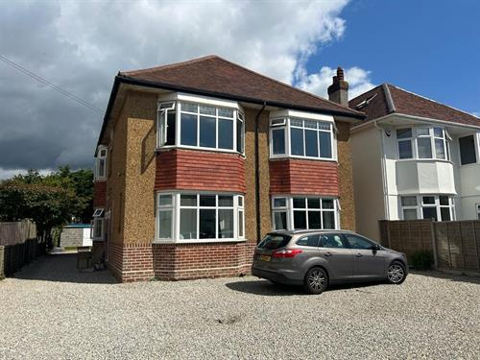

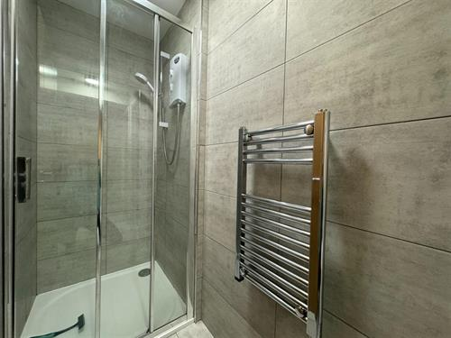
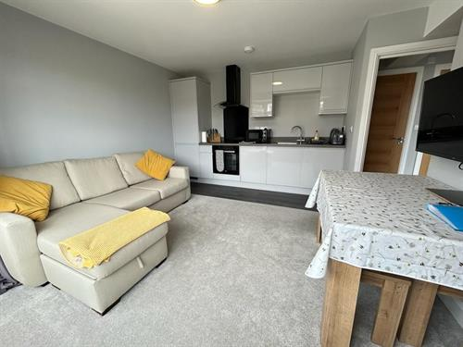
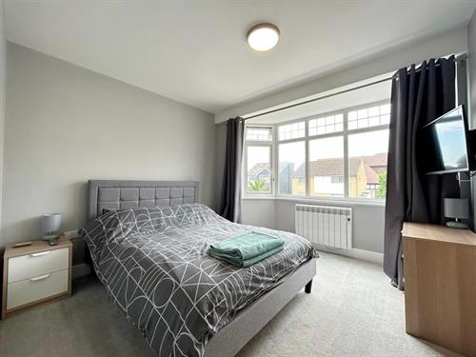
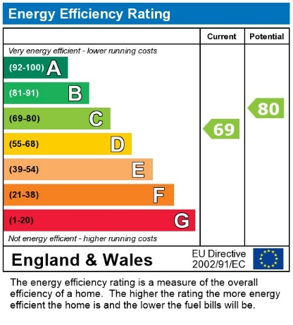
- Rent £995.00 PCM
- Deposit £1,148.07
- Off Road Parking
- Available October 1st
- Short Term Let
- Bike Storage
* Short Term Rental * Available Until Spring 2025 * First Floor Flat * Furnished * One Bedroom * Open Plan Living Room & Kitchen * Shower Room * Communal Garden & Off Road Parking * Bills Payable to Landlord Monthly in Advance (£215 pcm) *

