Portarlington Road, Bournemouth

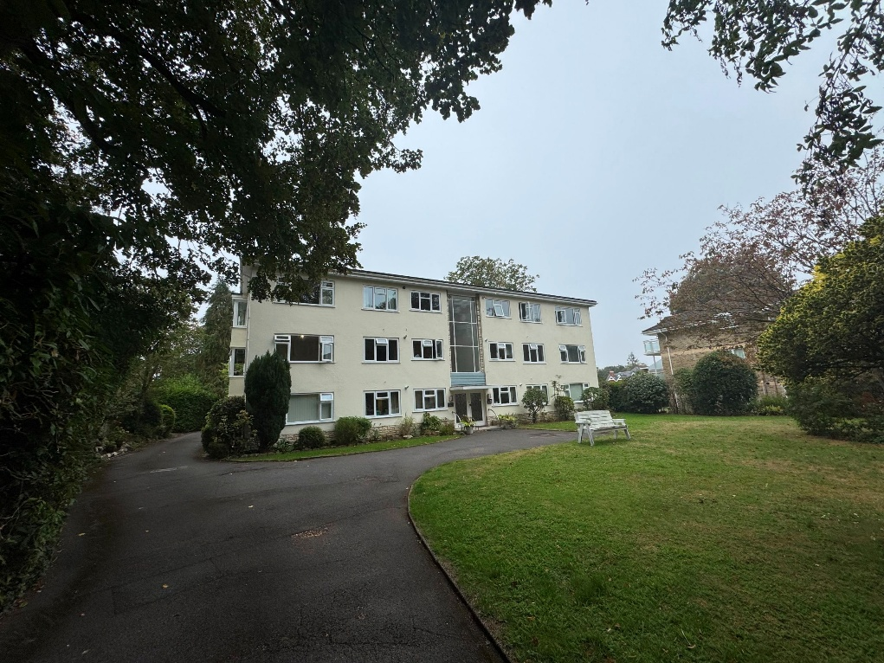

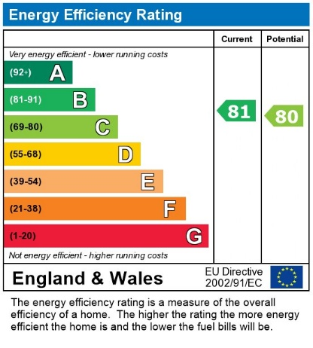
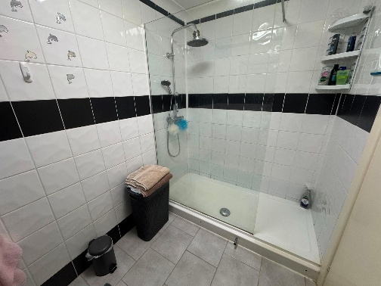
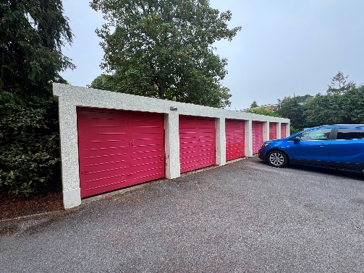
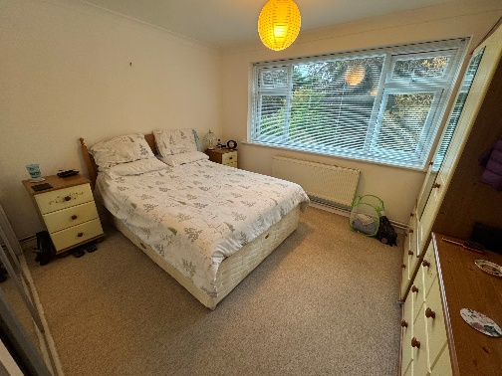
- Rent £1,250.00 PCM
- Deposit £1,442.30
- Council Tax Band C
- Available November
- Garage Parking
- Holding Deposit £288.46
First Floor Apartment * Large Entrance Hallway * Two Bedroom * Kitchen * Shower room * Separate WC * Living Room * GFCH * Double Glazed * White Goods * Allocated Parking * Garage * Available Early November *

