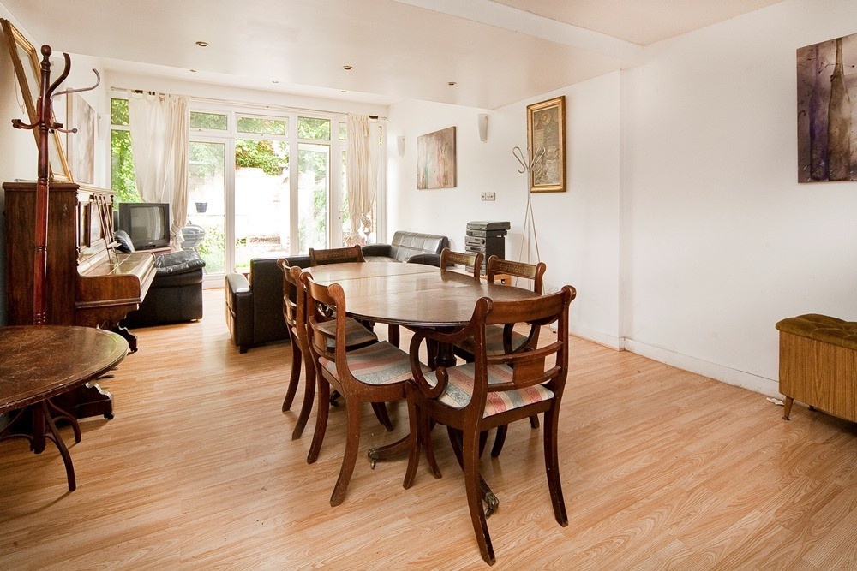


PR 900,000.00

Penderyn Way Tufnell Park N7

Yes

1 Reception
Kitchen
5 Bedroom
3 Bathroom

FOR SALE

Oliver Town | 189 Kentish Town Road | Kentish Town | London | NW5 2JU Tel: 0207 284 1222 Email: hello@oliverstown.com

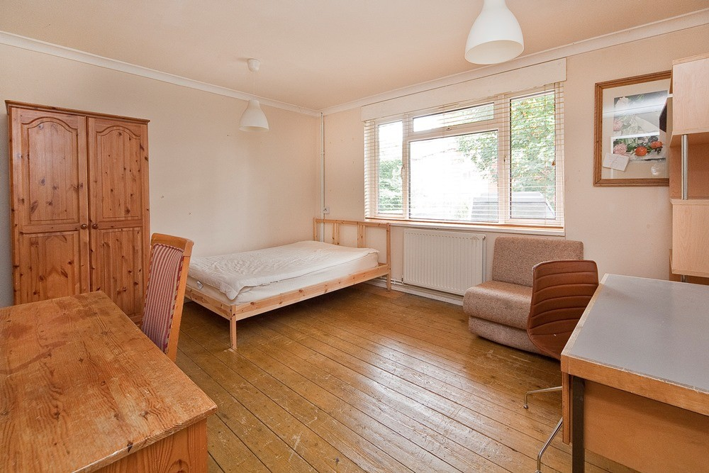

Penderyn Way Tufnell Park N7

PR 900,000.00
______________________________

___________________

Situated on Penderyn Way in the highly sought-after Tufnell Park area of N7, this impressive freehold town house offers an excellent opportunity to acquire a spacious family home. Constructed in the early 2000s, the property boasts five well-proportioned bedrooms and three modern bathrooms, providing ample accommodation for a growing household.
The ground floor features a generous reception room with wooden flooring, creating a warm and inviting living space. The property benefits from a private garden, ideal for outdoor entertaining or relaxing in a tranquil setting.
Offered with a guide price of £900,000, this residence combines contemporary living with the convenience of a prime location. The property holds an EPC rating of D and presents a versatile layout to suit various lifestyle needs.
Early viewing is highly recommended to fully appreciate the space and potential this town house offers.
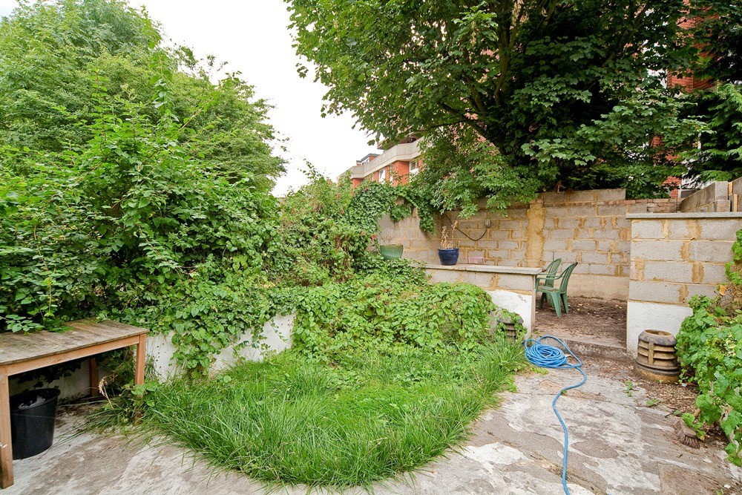
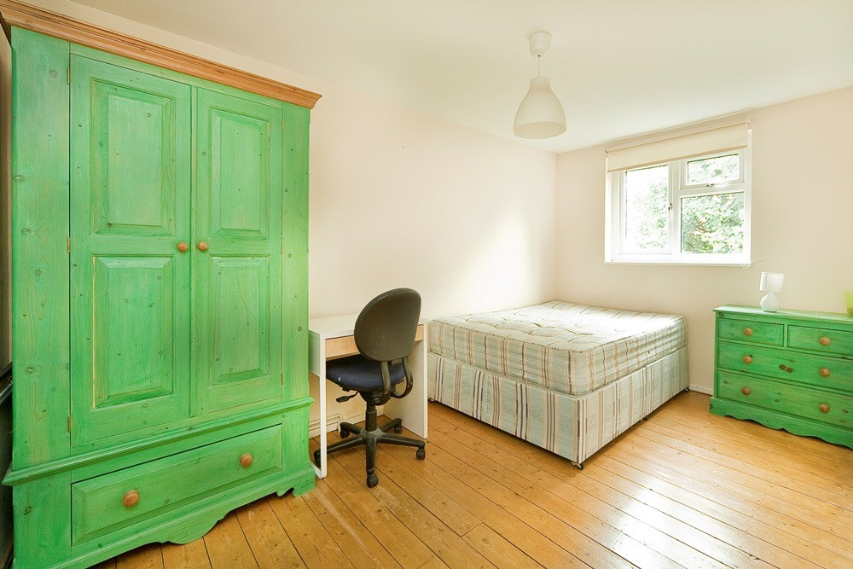
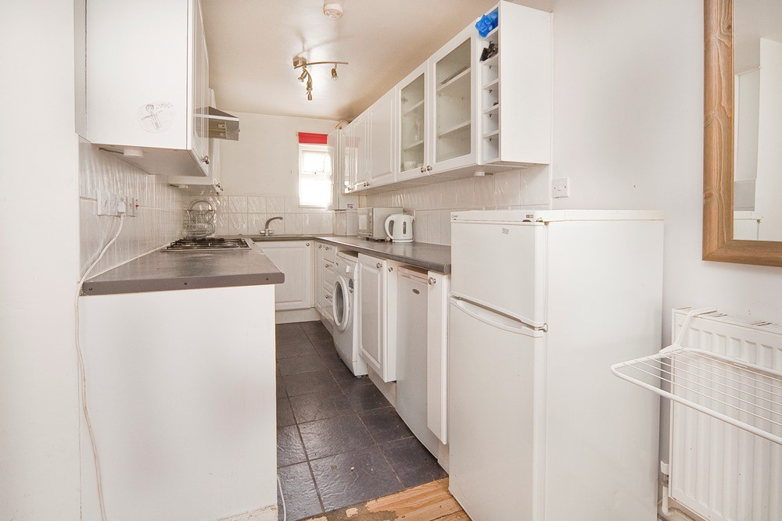
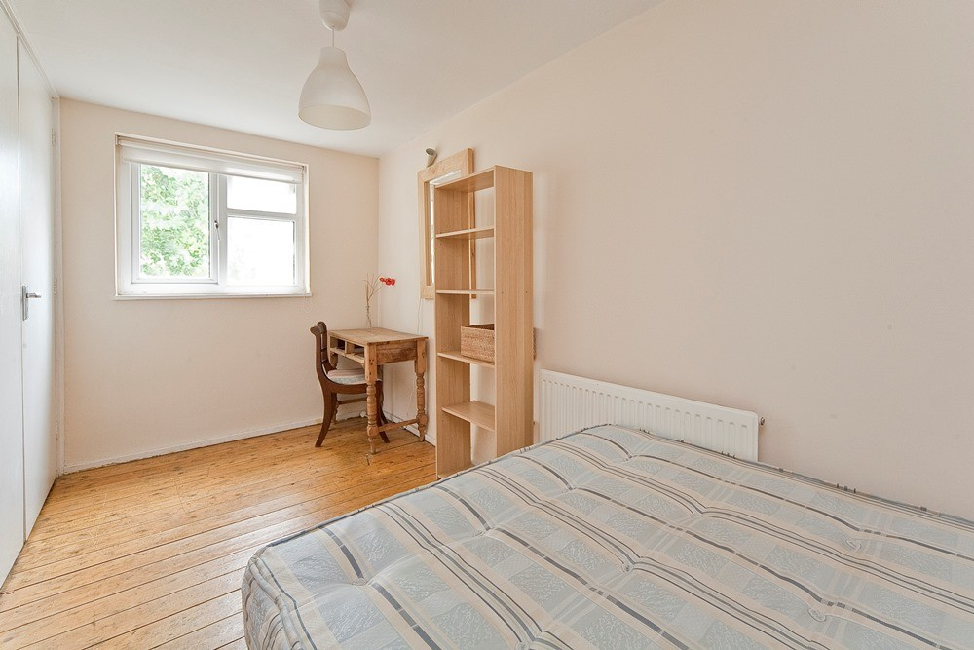
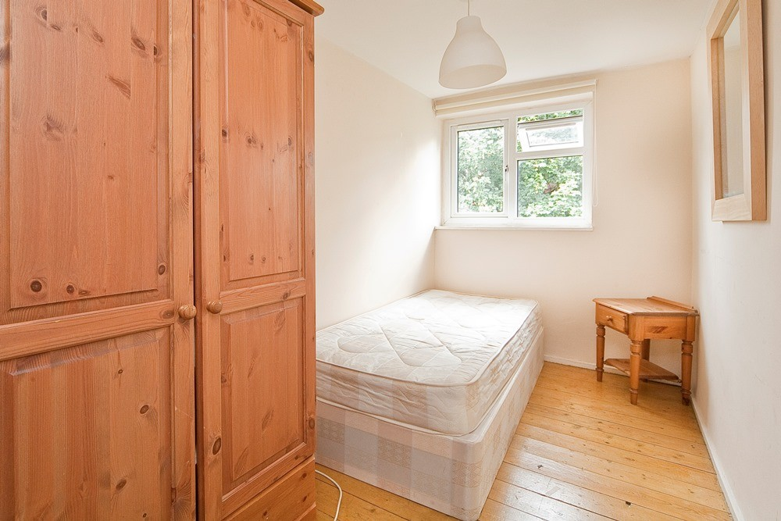
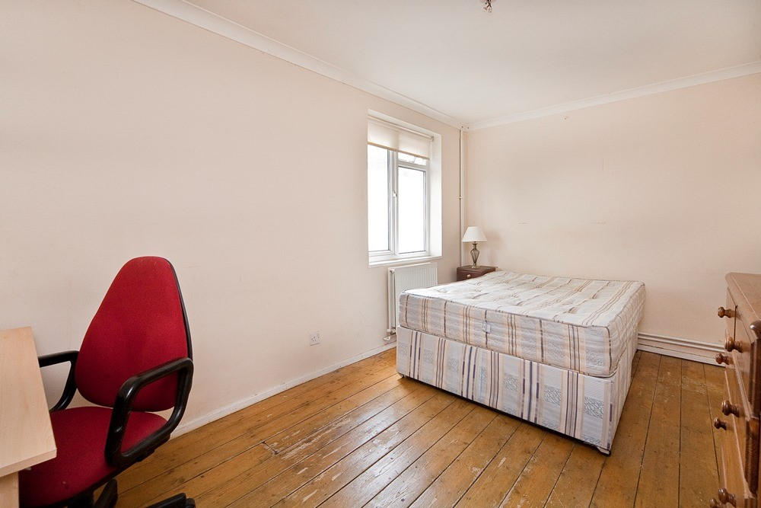
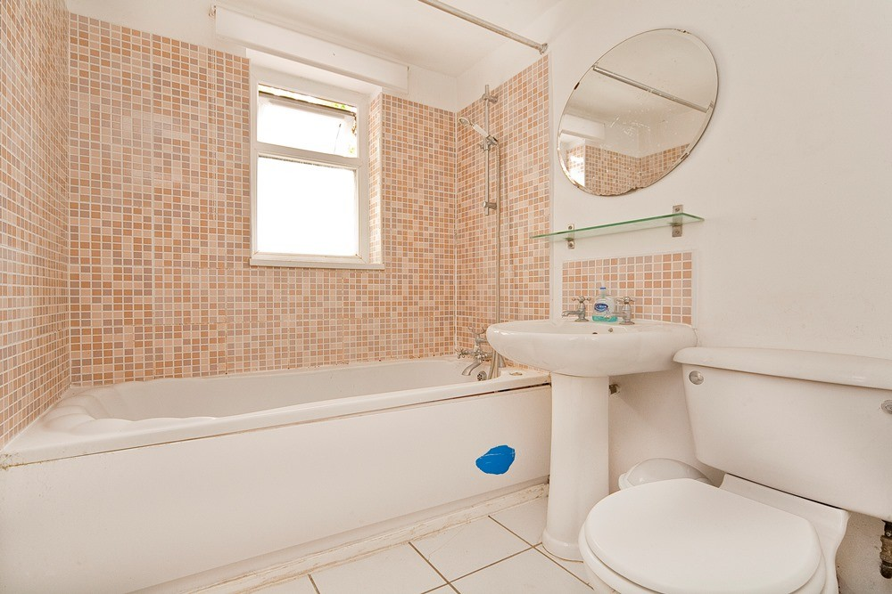

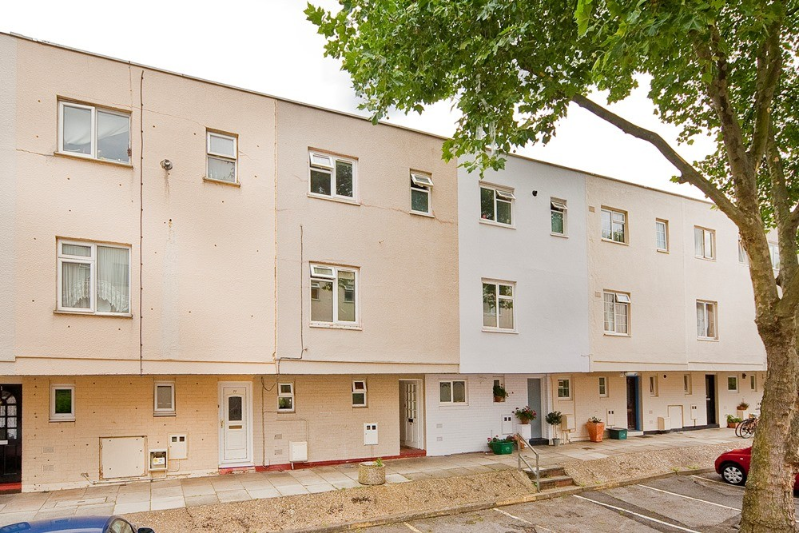





5 Bedroom
3 Bathroom
1 Reception
Yes
EPC Band
Council Tax Band
900,000.00
Freehold

64

London Borough of Islington
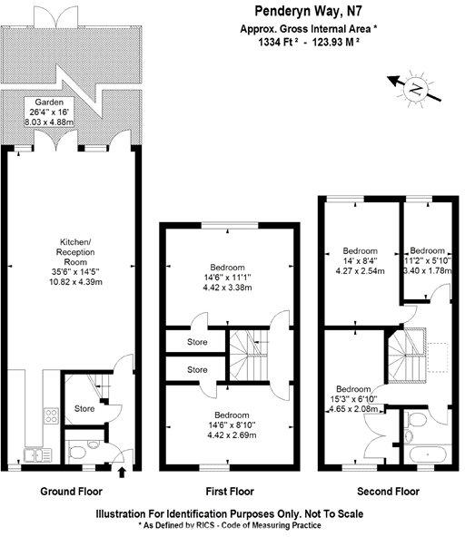
KENTISH TOWN | 189 Kentish Town Rd | London | NW5 2JU | T: 020 7284 1222 | hello@oliverstown.com
ASSOCIATED MAYFAIR | 121 Park Lane | London | W1K 7AG | T: 020 3368 8602 | hello@oliverstown.com

