Southwood Avenue , Southbourne

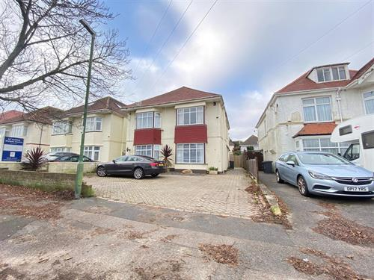

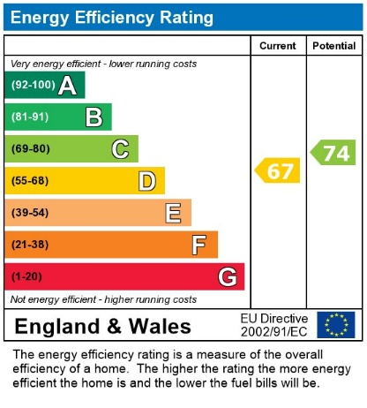
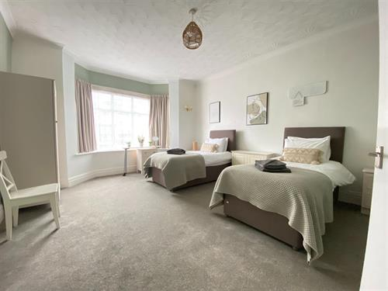
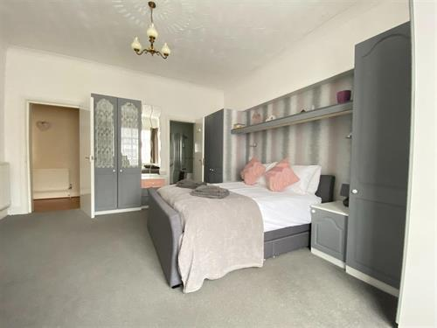
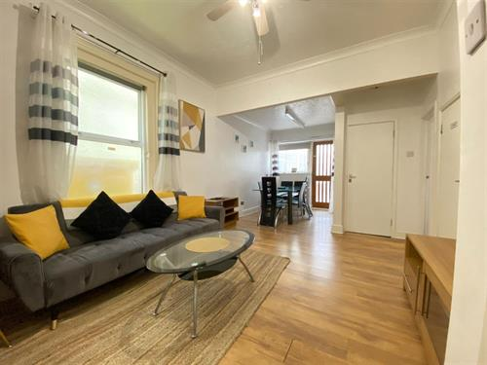
- Rent £1,250.00 PCM
- Deposit £1,442.30
- Off Road Parking
- Available October
- Short Term Let
- Holding Deposit £288.46

* Short Term Let * Fully Furnished * Extremely Spacious Ground Floor Flat * Furnished or Unfurnished* Two Double Bedrooms * En Suite to Master * Shower Room * Living/Dining Room * Conservatory * Garden * Off Road Parking * GFCH * Available October *

